Year 10 Semester One - Paper B

Mathematics Examination
Part Two: Calculators Allowed

Name ________________________________ Teacher _______________________

TIME ALLOWED FOR THIS PAPER
Reading time before commencing : 5 minutes.
Working time for paper : 50 minutes.

MATERIAL REQUIRED /RECOMMENDED FOR THIS PAPER

TO BE PROVIDED BY THE SUPERVISOR
This question paper comprising 6 questions.
Attempt ALL questions.
Total marks for the paper : 75
Answers are to be written on this test booklet in the spaces provided.

TO BE PROVIDED BY THE CANDIDATE
Pens, pencils, eraser, ruler, Scientific Calculator
One (1) A4 page of notes (handwritten, photocopied or typed on both sides) that may be either personally or commercially produced.

INSTRUCTIONS TO CANDIDATES
Write all answers in the spaces provided - if working is completed on extra pages, indicate on the original question that your working continues elsewhere.
If extra paper is needed in any section, please ask one of the supervisors.

Show all working clearly, in sufficient detail to allow your answers to be checked readily and for marks to be awarded for reasoning. No marks will be awarded to incorrect answers without supporting reasoning.

Question | Possible Marks | Your Mark
1 | 9
2 | 16
3 | 17
4 | 10
5 | 15
6 | 8
Total | 75
Question 1 [9 marks]

a) Expand then factorise the expression (x + 1)² -9.

[2]

b) Set your factorised expression from part a) to zero then solve for x.

[2]

c) Draw a graph of the curve, y =(x + 1)² -9, on the following axes. Indicate clearly the turning point, y intercept and line of symmetry.
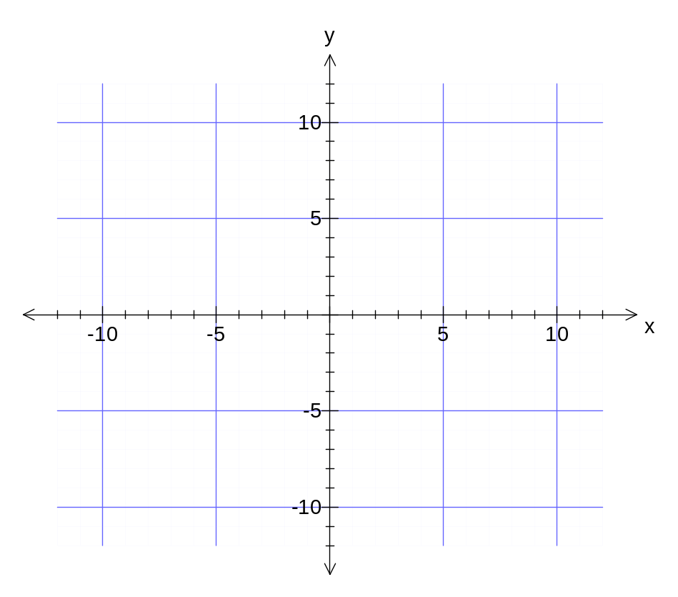
[4]
d) How are your answer(s) in part b) significant to this part c)?

[1]
Question 2 [16 marks]

a) (i) Sketch a diagram for the net of the following triangular prism. Indicate all of the lengths of each polygon that make up the net.

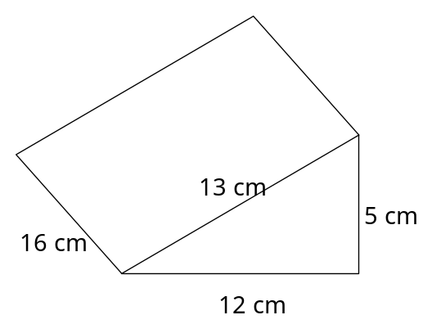
[3]
(ii) Calculate the surface area of the prism.

[5]
(iii) Calculate the volume of the prism.

[3]

b) A square pyramid has a square base with sides of 4.5 cm and a perpendicular height of 6.2 cm. What is its volume?

[3]

c) (i) How many square centimetres in a square metre?

[1]

(ii) How many cubic centimetres in a cubic metre?

[1]
Question 3 [17 marks]
a) Find the perimeter and area of the following shapes, to 1 decimal place.
(i) (ii)
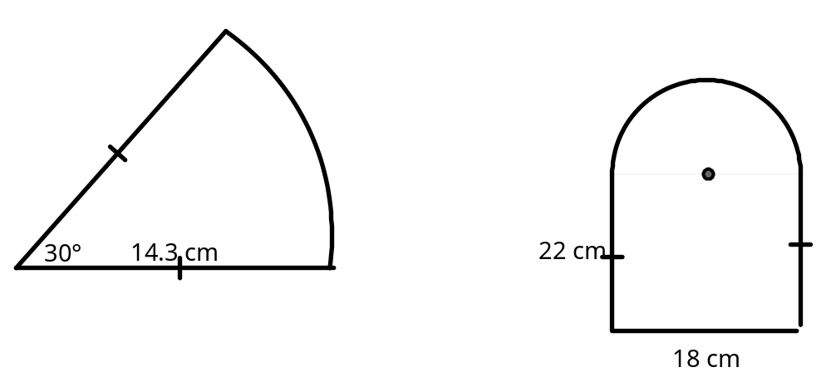

[9]

b) Find the volume and surface area of a cylinder that has a radius of 7.4 cm and a height of 10.5 cm

[5]

c) What is the volume of a cone with base radius of 3.4 cm and perpendicular height of 9 cm.

[3]

Question 4 [10 marks]

a) (i) Which of the following triangles are similar? Why?
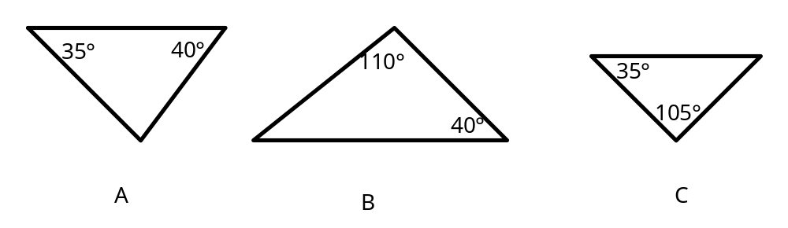

(ii) List then briefly explain the other conditions for similar triangles.

[4]

b) i) Δ LMN ~ Δ XYZ. Determine XZ (Note: measurements are in centimetres).

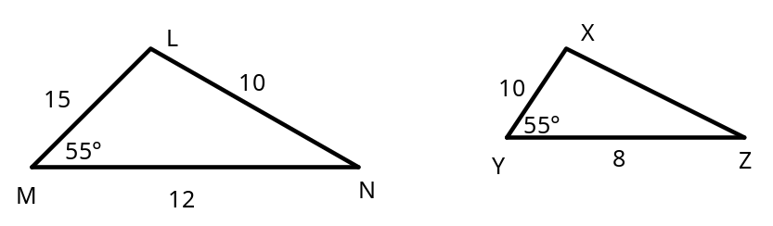

[3]

(ii) Δ ADE ~ Δ ABC. Determine DB. (Note: measurements are in centimetres).
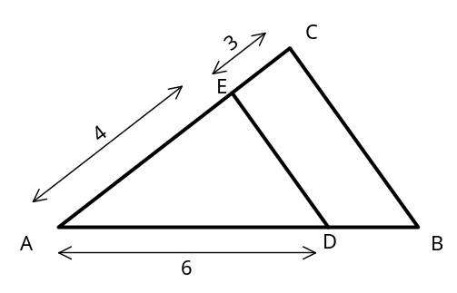
[3]
Question 5 [15 marks]

a) Use your calculator to evaluate the following (to 4 decimal places):

(i) sin 55° (ii) tan 20°

[2]
b) Consider the following right triangle.
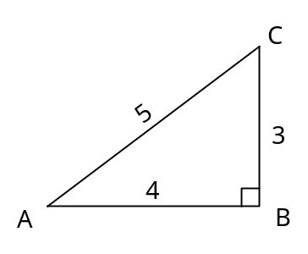 | (i) State the ratio for:  cos A:  sin A:  tan A:  (ii) Calculate the size of angle A.

[5]

c) (i) At a point 40 metres from the foot of a monument the angle of elevation of the top of the monument is 70°. How high is the monument?

[3]

(ii) The ladder is placed on level ground and just reaches the top of a building. It makes an angle of elevation of 62° with the ground. Determine the length of the ladder.

[5]

Question 6 [8 marks]

Blair invests $5 400 for 3 years at an interest rate of 3.4% per annum.

a) How much interest is earned if the investment is simple interest?

[3]
b) How much interest is earned if the investment is compounded yearly?

[3]
c) Is the amount for b) greater or less than a)? Explain why this is so.

[2]

